Software Design Specification

**Group Members:**

Gaurav Kumar Singh (19BCE2119)

Piyush Rajput (19BCE0689)

Ayush Gupta (19BCE2422)

Aryan Singh (19BCE2295)

USE CASE DIAGRAM

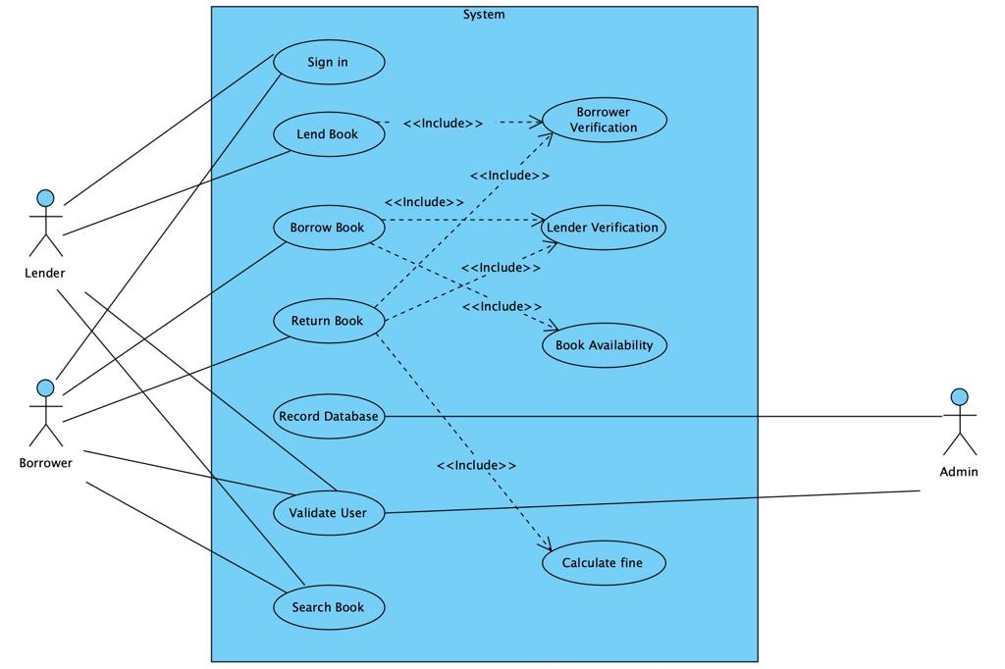

CLASS DIAGRAM

SEQUENCE DIAGRAM

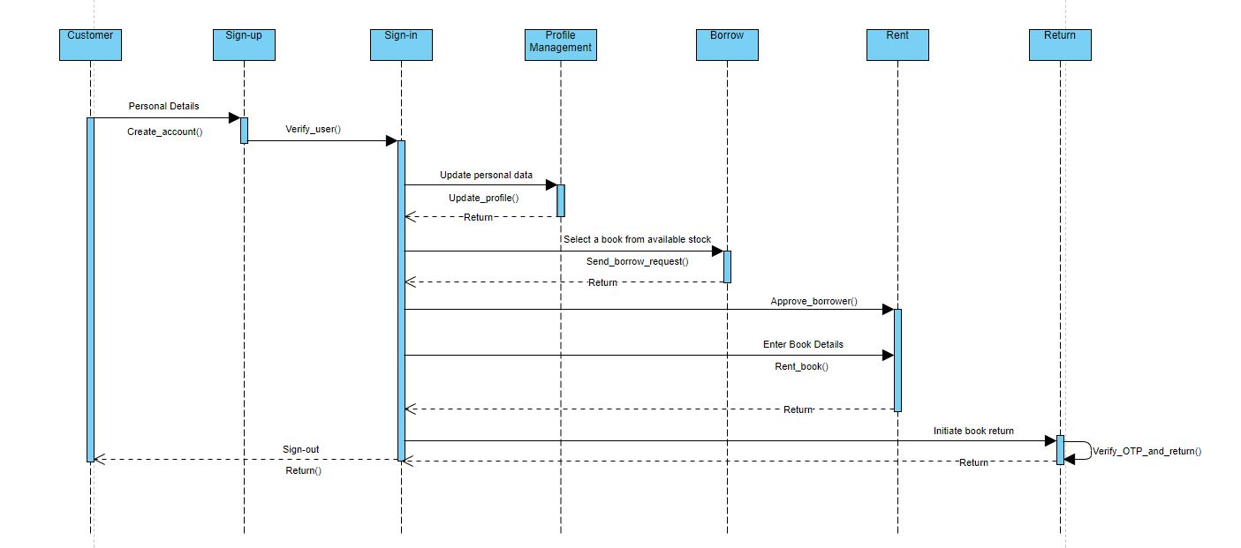

COLLABORATION DIAGRAM

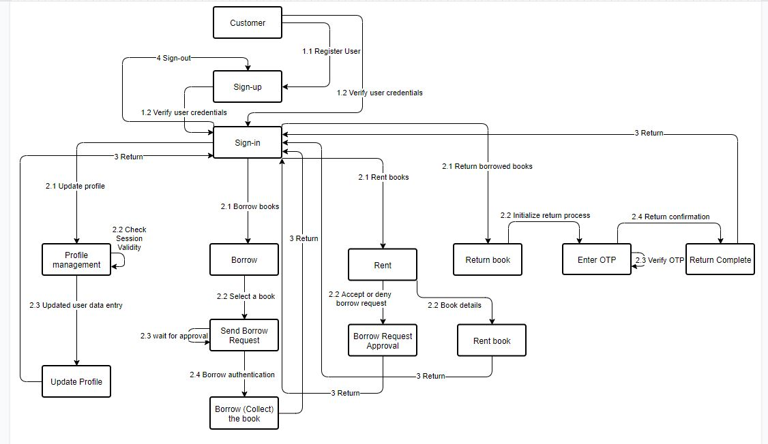

COMPONENT DIAGRAM